l

**School of Engineering and Technology**

**ARTIFICIAL INTELLIGENCE**

(Practical File)

**18BCS-0AI32L**

**Submitted by:**

Name: Ankush Metla

Roll Number: 170BTCCSE011

Branch: Computer Science & Engg.

Year/Sem: 5rd Semester

Year/Sem: 3rd Semester

**Submitted to:**

Faculty: Mrs. Ujjawal

**INDEX**

|  |  |  |
| --- | --- | --- |
| S.No. | Title | Signature |
|  |  |  |
|  |  |  |
|  |  |  |
|  |  |  |
|  |  |  |
|  |  |  |
|  |  |  |
|  |  |  |
|  |  |  |
|  |  |  |
|  |  |  |
|  |  |  |
|  |  |  |
|  |  |  |
|  |  |  |

PYTHON (PROGRAMMING LANGUAGE)

Python is an [interpreted](https://en.wikipedia.org/wiki/Interpreted_language" \o "Interpreted language) , [high-level](https://en.wikipedia.org/wiki/High-level_programming_language), [general-purpose](https://en.wikipedia.org/wiki/General-purpose_programming_language) [programming language](https://en.wikipedia.org/wiki/Programming_language). Created by [Guido van Rossum](https://en.wikipedia.org/wiki/Guido_van_Rossum) and first released in 1991, Python's design philosophy emphasizes [code readability](https://en.wikipedia.org/wiki/Code_readability) with its notable use of [significant whitespace](https://en.wikipedia.org/wiki/Off-side_rule). Its language constructs and [object-oriented](https://en.wikipedia.org/wiki/Object-oriented_programming) approach aim to help programmers write clear, logical code for small and large-scale projects.

**VARIABLES**

[Python](https://www.geeksforgeeks.org/python-programming-language/) is not “statically typed”. We do not need to declare variables before using them, or declare their type. A variable is created the moment we first assign a value to it.

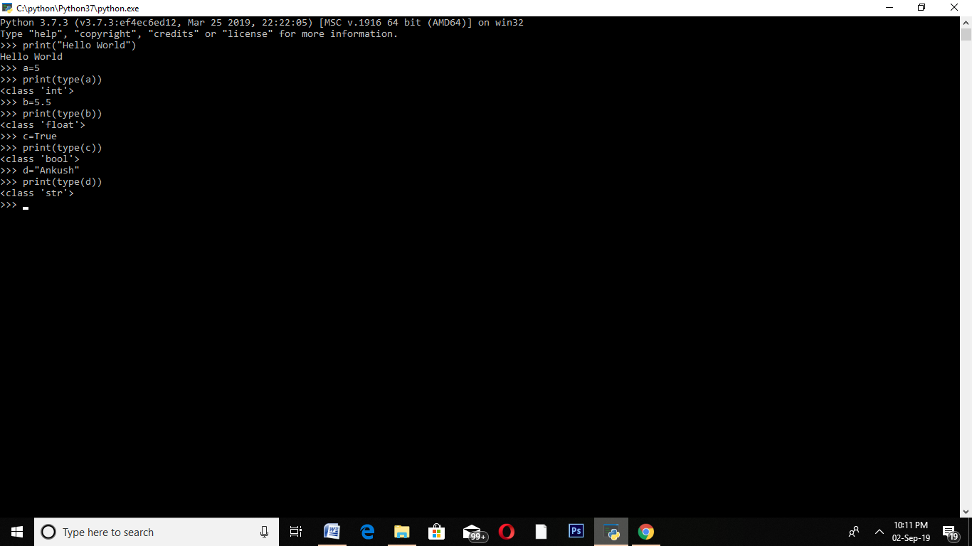

**OPERTORS**

**Arithmetic operators:**

Arithmetic operators are used to perform mathematical operations like addition, subtraction, multiplication and division.

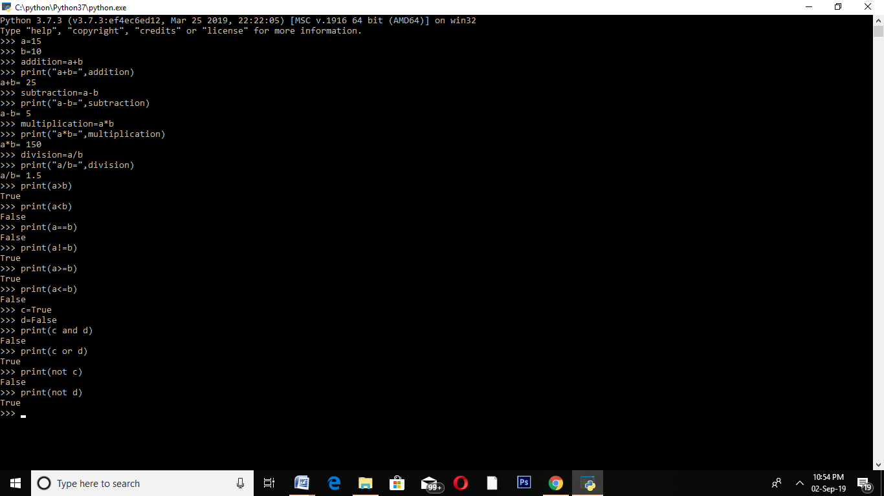

**Relational Operators:**

Relational operators compares the values. It either returns True or False according to the condition.



**Logical operators:**

Logical operators perform **Logical AND**, **Logical OR** and**Logical NOT** operations.



**STRINGS**

In Python, Strings are arrays of bytes representing Unicode characters. However, Python does not have a character data type, a single character is simply a string with a length of 1. Square brackets can be used to access elements of the string.

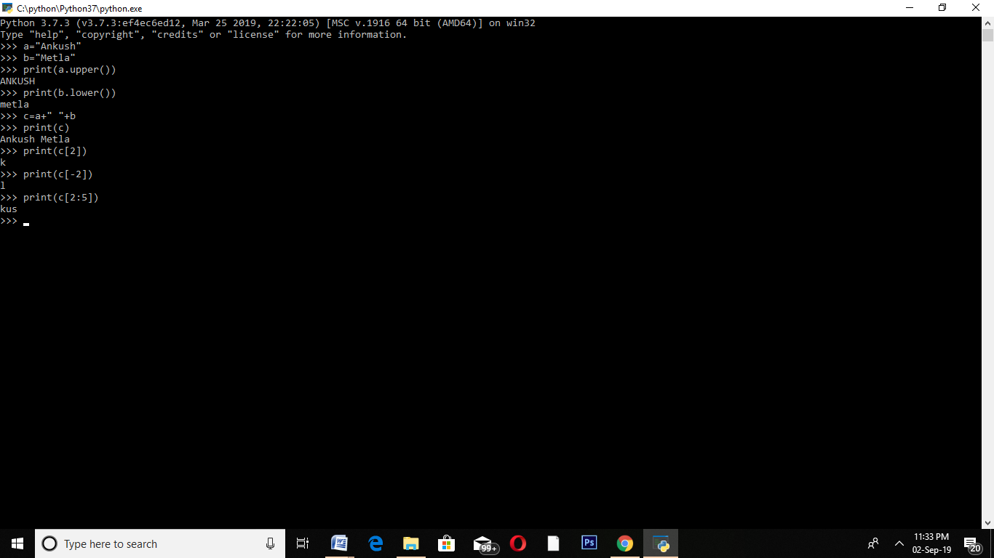

**LISTS**

Lists are just like the arrays, declared in other languages. Lists need not be homogeneous always which makes it a most powerful tool in [Python](https://www.geeksforgeeks.org/python-programming-language/). A single list may contain DataTypes like Integers, Strings, as well as Objects. Lists are also very useful for implementing stacks and queues. Lists are mutable, and hence, they can be altered even after their creation.

In Python, list is a type of container in Data Structures, which is used to store multiple data at the same time. Unlike Sets, the list in Python are ordered and have a definite count. The elements in a list are indexed according to a definite sequence and the indexing of a list is done with 0 being the first index. Each element in the list has its definite place in the list, which allows duplicating of elements in the list, with each element having its own distinct place and credibility.

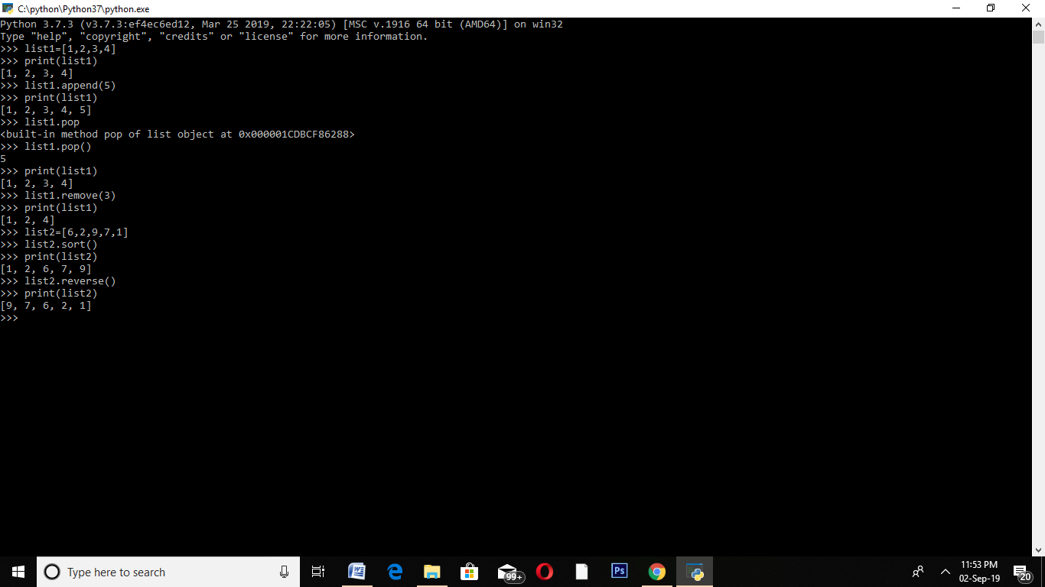

**SETS**

A Set is an unordered collection data type that is iterable, mutable, and has no duplicate elements. Python’s set class represents the mathematical notion of a set. The major advantage of using a set, as opposed to a list, is that it has a highly optimized method for checking whether a specific element is contained in the set. This is based on a data structure known as a [hash table](https://www.geeksforgeeks.org/hashing-set-1-introduction/).

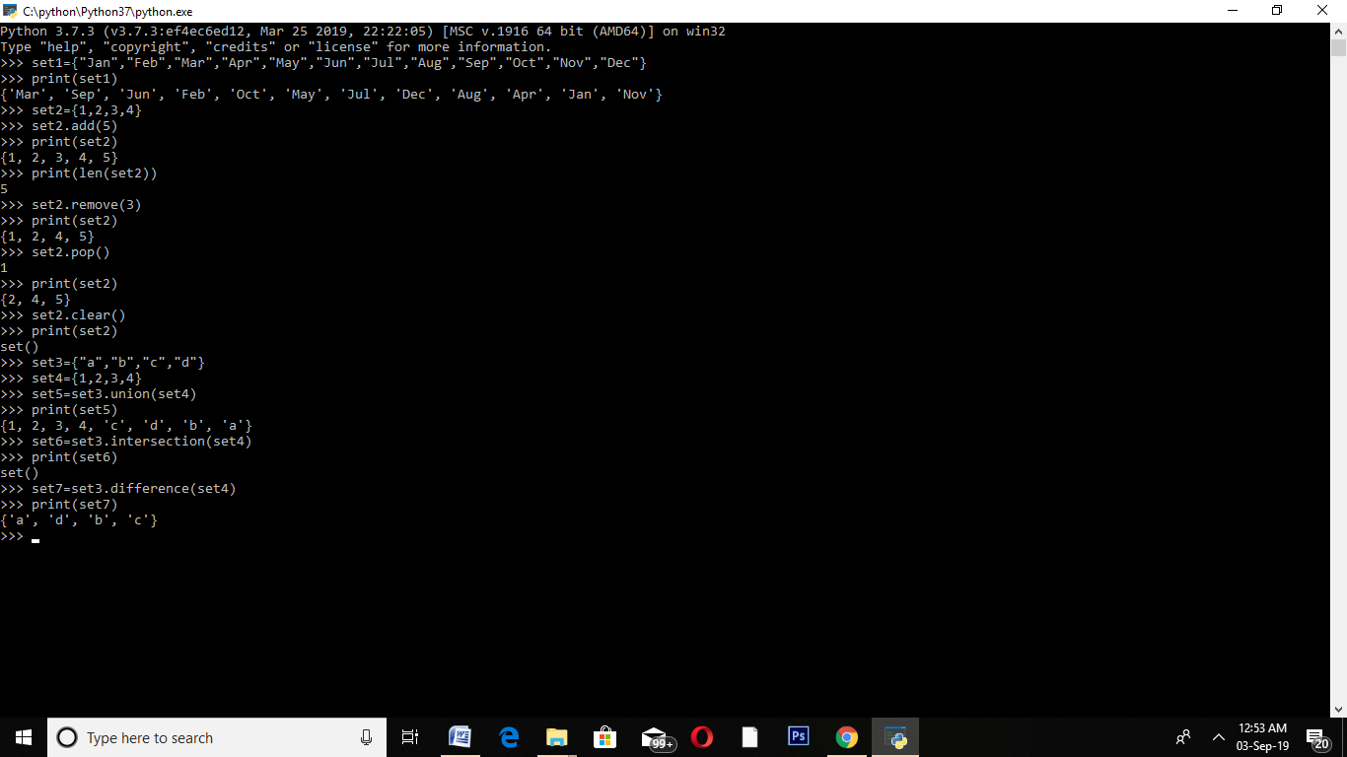

**TUPLES**

A Tuple is a collection of Python objects separated by commas. In someways a tuple is similar to a list in terms of indexing, nested objects and repetition but a tuple is immutable unlike lists which are mutable.

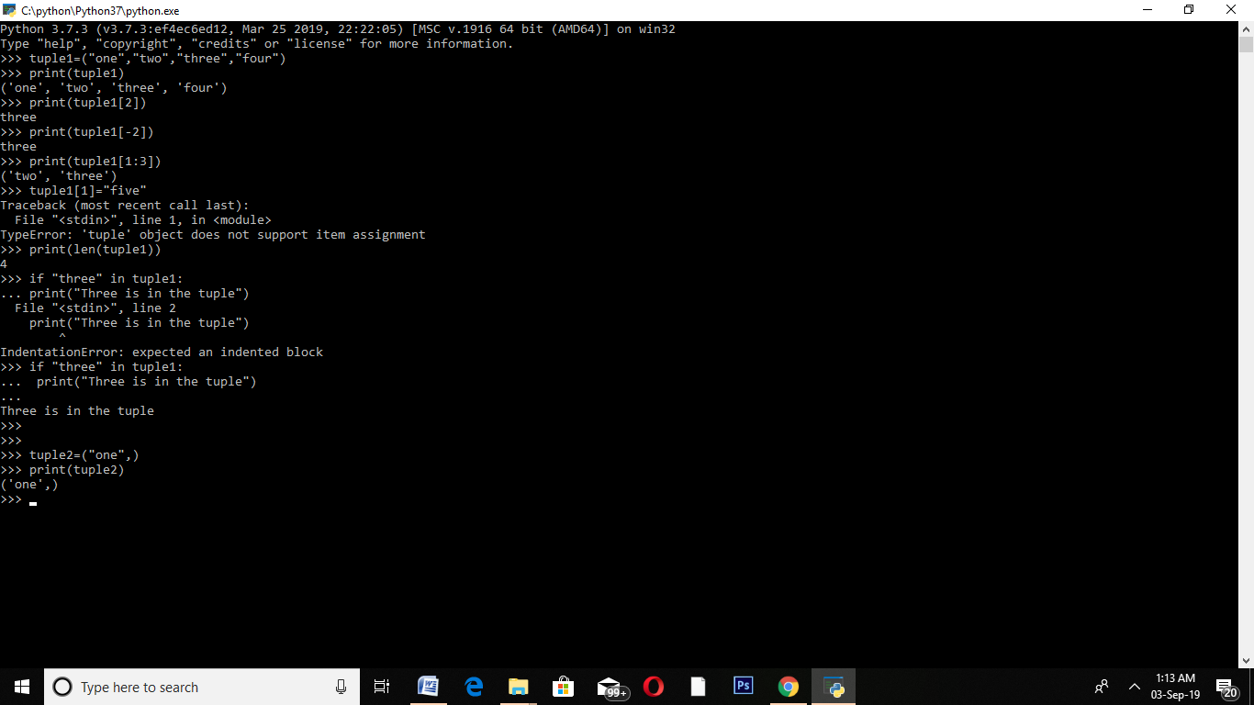

**DICTIONARY**

**Dictionary**in Python is an unordered collection of data values, used to store data values like a map, which unlike other Data Types that hold only single value as an element, Dictionary holds key:value pair. Key value is provided in the dictionary to make it more optimized. Each key-value pair in a Dictionary is separated by a colon **:**, whereas each key is separated by a ‘comma’.

A Dictionary in Python works similar to the Dictionary in a real world. Keys of a Dictionary must be unique and of immutable data type such as Strings, Integers and tuples, but the key-values can be repeated and be of any type.

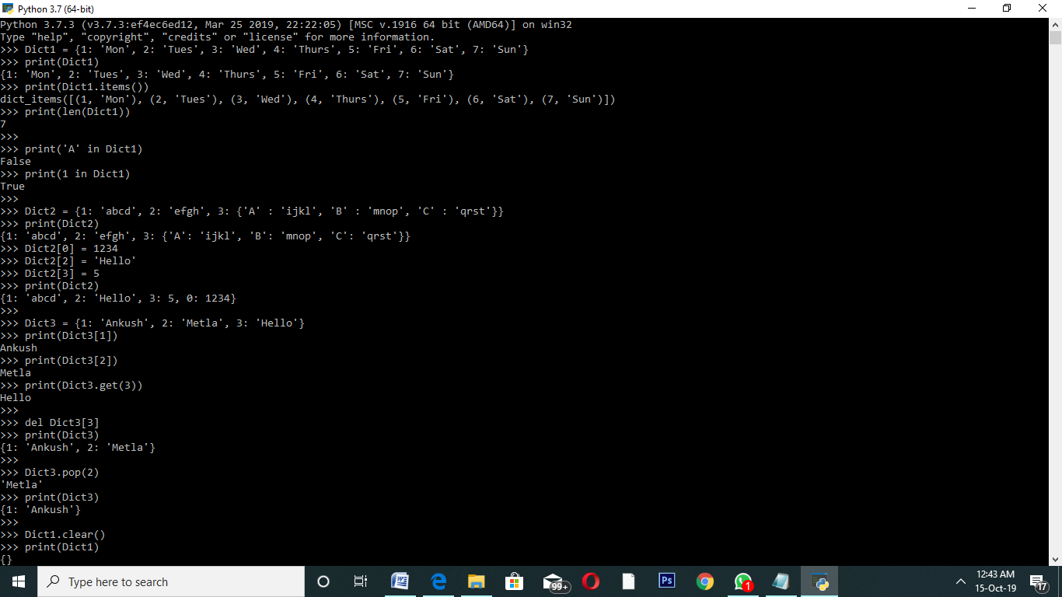

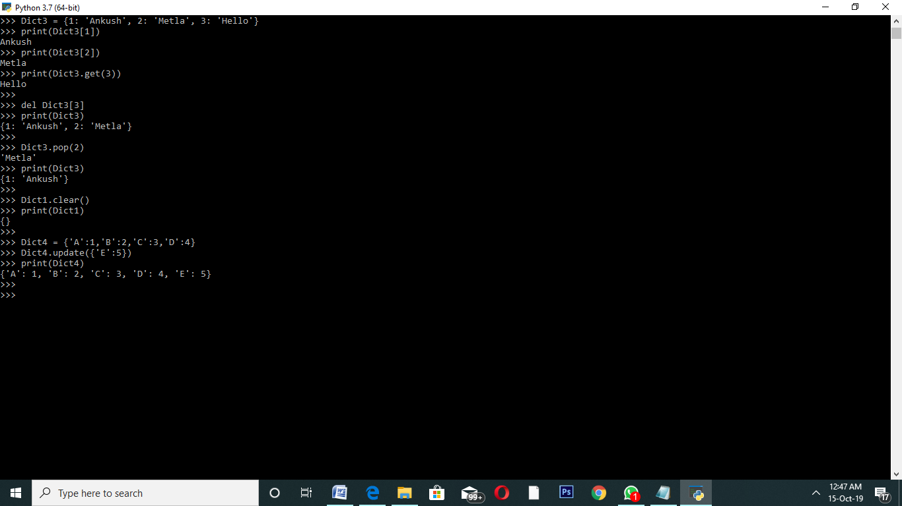

**NUMPY**

Numpy is a general-purpose array-processing package. It provides a high-performance multidimensional array object, and tools for working with these arrays. It is the fundamental package for scientific computing with Python.  
Besides its obvious scientific uses, Numpy can also be used as an efficient multi-dimensional container of generic data.

Array in Numpy is a table of elements (usually numbers), all of the same type, indexed by a tuple of positive integers. In Numpy, number of dimensions of the array is called rank of the array.A tuple of integers giving the size of the array along each dimension is known as shape of the array. An array class in Numpy is called as ndarray. Elements in Numpy arrays are accessed by using square brackets and can be initialized by using nested Python Lists.

